# Main Solution

Set Burp Suite to intercept all requests and responses under proxy settings:

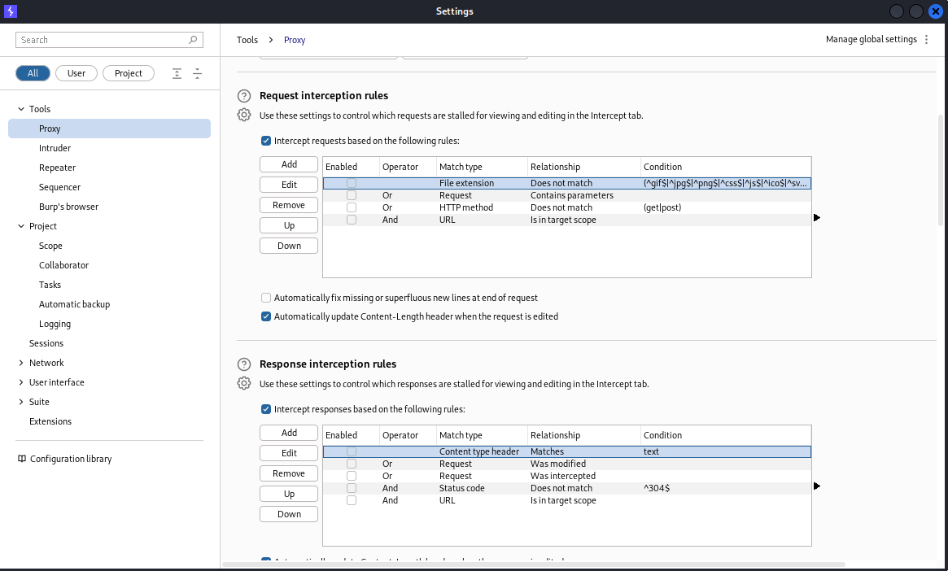

Reload the page and start the game, you would notice that at some point during the loading phase the page makes a GET request to the /api/options, here you can see that there is a secret portion which you just need to set the command to “Blip-blop, in a pickle with a hiccup! Shmiggity-shmack”

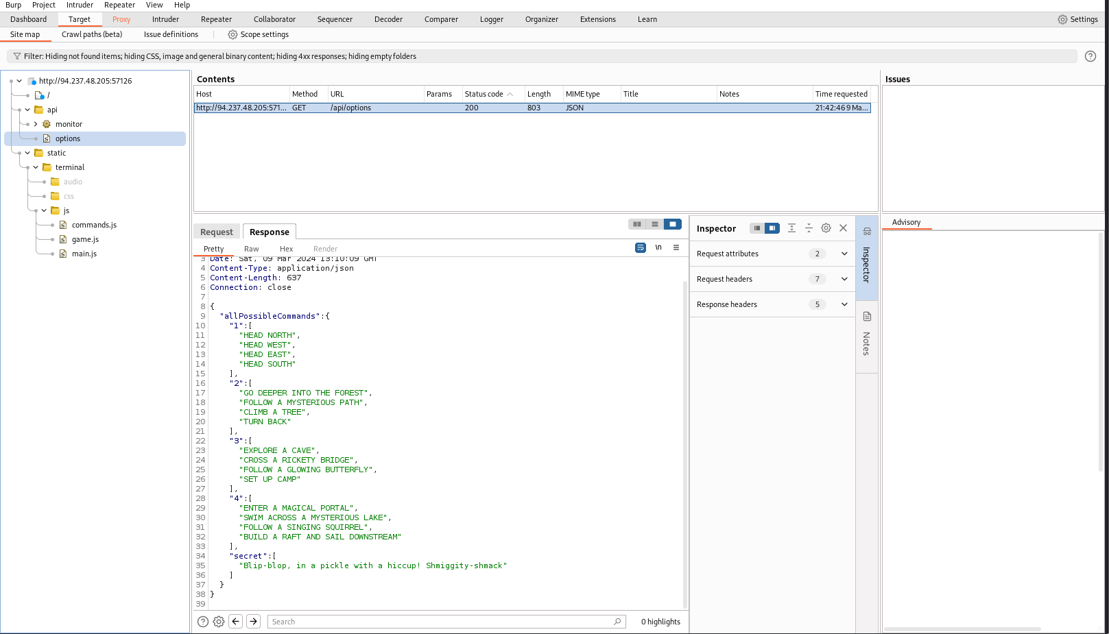

Testing this theory, indeed the message returns the flag for this challenge

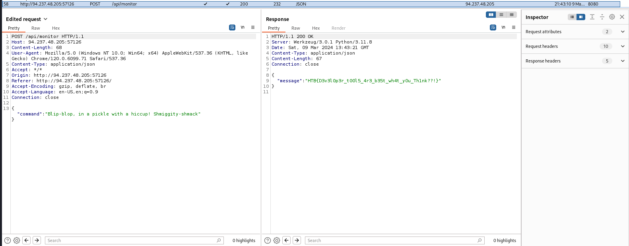

# Rabbit Hole 1:

Under the main.js we can see that it does a check to see if message contains HTB{ or Game Over

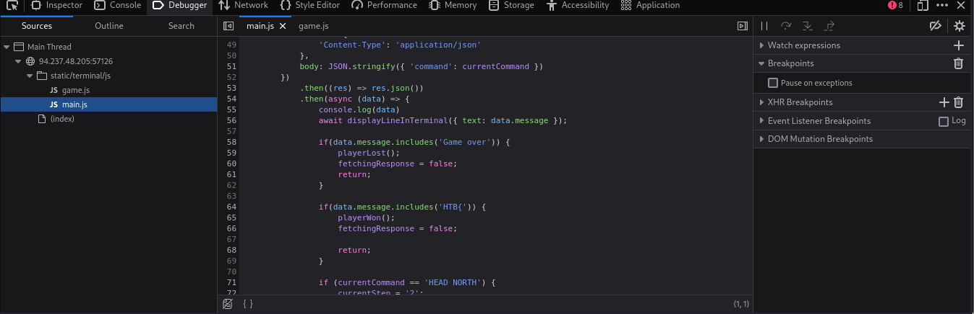

BUT in the game.js we can see that yes playerWon only seems to show some form of message so to test the theory, let’s dive into the rabbit hole, to do this you would also need to intercept both request and response!

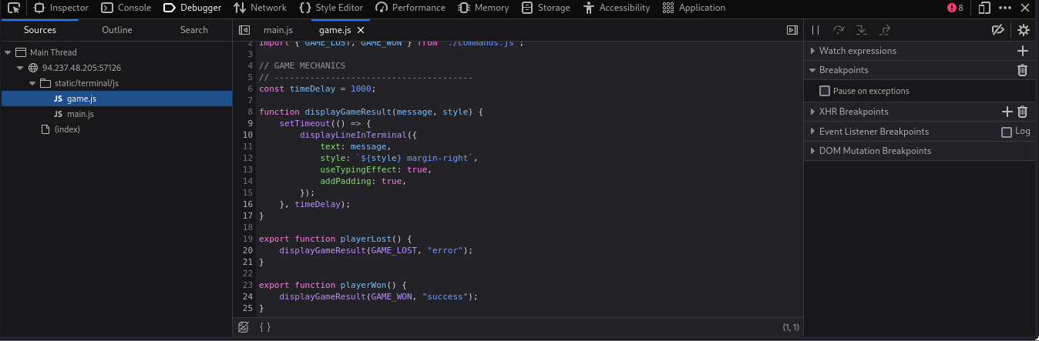

For example, in this case the message returned would cause the game to give you the game over message, so i modified the response’s message content to only “HTB{“ which prints the congrats message but nothing else…

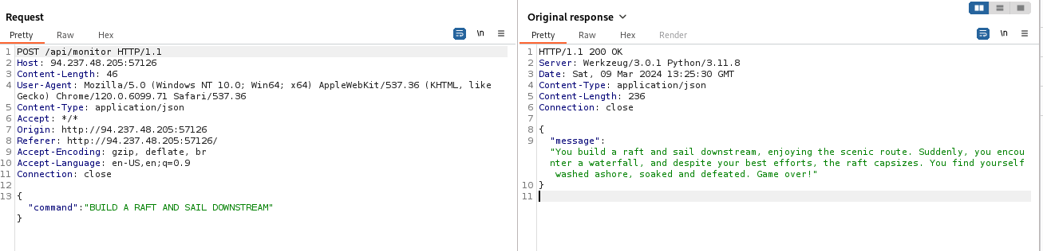

TLDR: All it does is print congratulations! You have won…etc, no flags :’(